TITLE SLIDE

Good day, I’m Phil Castle, the new Director of the Division of Cancer Prevention. I’m pleased to meet the members of the National Cancer Advisory Board for the first time in my new role, and I look forward to meeting you in person, hopefully someday soon.

Let me say a little about myself. This is a homecoming for me. I was a fellow in the Cancer Prevention Fellowship Program from 1999-2002. I then stayed on at the NCI in the Division of Cancer Epidemiology and Genetics, as a Research Fellow, Investigator, and finally a Senior, Tenured Investigator. I left the NCI in early 2011 to become the Chief Science Officer at the American Society for Clinical Pathology. I came back to the NCI as Director of DCP after becoming a tenured Professor at Albert Einstein College of Medicine, where I had received funding from the NCI, CDC, and USAID. My professional interests include epidemiology of human papillomaviruses (HPV) and cervical/anogenital cancer; science and translation of cancer prevention strategies; cancer screening; and global cancer health disparities.

I’m honored to be chosen to lead the division where I was once a fellow. The scope of our work, prevention, early detection, and supportive care research, is remarkable and I look forward to working with the amazing DCP team to revolutionize and accelerate prevention of cancer and its consequences.

I want to acknowledge the work of the DCP leaders who came before me: Dr. Debbie Winn, Dr. Barry Kramer, and Dr. Peter Greenwald. Thank you for your work. Debbie has been an amazing mentor in my transition into this role and I cannot thank her enough.

I’d also like to thank my DCP colleagues for their help and feedback on today’s presentation, especially Dr. Worta McCaskill-Stevens, who heads the NCI Community Oncology Research Program, also known as NCORP.

As Ned mentioned, we are concerned about recruitment to clinical trials during this global pandemic, and especially the large breast cancer screening trial known as TMIST, where accrual was already below target and has further slowed during the pandemic. As stewards of research funding, we want to be transparent and seek counsel from our advisors.

I also want to thank Dr. Etta Pisano and the entire ECOG-ACRIN research network and the investigators involved in the trial for their continuing hard work. And I most definitely want to thank the nearly 30,000 women currently enrolled in TMIST. Your willingness to participate in clinical trials is appreciated and we care about you.

SLIDE 2

Introduction
- The pandemic has decreased accrual to our trials.
- As some of these trials take a long time to complete, it is important to ask if these trials are still poised to answer the critical research questions they were intended to address in a timely fashion.
- We consider on-going reviews of our prevention trials as our stewardship responsibility.
Today I would like to focus on TMIST, DCP’s largest trial.

SLIDE 3

TMIST is a study conducted by the ECOG-ACRIN clinical trials group in concert with NCI. Its primary aim is shown here.

Primary Aim and Summary of TMIST
- To determine whether the cumulative rate of advanced breast cancer in women undergoing screening with tomosynthesis plus digital mammography (“3-D”) is reduced compared to digital mammography (“2-D”) alone.
- Advanced cancer is defined as any cancer diagnosed in the 4.5 years after study entry that is metastatic or a large tumor (based on subtype).
- Mortality is not the endpoint of TMIST.
- TMIST is being conducted at NCORP and non-NCORP sites and is being led by Eastern Cooperative Oncology Group (ECOG) and the American College of Radiology Imaging Network (ACRIN) (ECOG-ACRIN).
- TMIST was originally projected to complete enrollment by 2020 (2.5 years of accrual) (5,500 per month) and to finish in 2025.
- Proposed Sample Size = 165K participants; current enrollment is <30K.
- Estimated Costs for 2021-4: $93.9 Million.

SLIDE 4

Here you see the study schema.
Nearly 30,000 women are currently enrolled on TMIST to date. I again want to thank and acknowledge them for their willingness to volunteer in clinical trials and for their continuing participation in TMIST. And none of this would have been possible without the hard work and dedication of the TMIST team, the DCP staff, and the NCORP and non-NCORP clinical sites and their clinical teams.

SLIDE 5
Initially, TMIST planned to open approximately 100-110 clinical sites to enroll women. The number of sites to date are shown here.

Clinical Sites

The graph above shows the ramping up of accruing clinical sites over time.
- 112 sites are currently open to accrual in CTSU
- 99 sites have enrolled at least 1 participant
- 13 sites are currently open in CTSU but have no enrollments as of 9/1/2020
- 23 US sites and 3 international sites are in the process of submitting qualifications to activate TMIST

CTSU=Cancer Trials Support Unit
CCTG=Canadian Cancer Trials Group

SLIDE 6

Accruals and the Impact of COVID

To Date
- Target Accrual: 165K (Average ~5,500 per month) (completion of enrollment)
- Actual Accrual: <30K (Average <1,500 per month)
- Maximum enrollment of ~1,700 (January & February of 2020)
- Impact of COVID: ~50% reduction in enrollment (vs. 1,700 per month) for a 6-month period from March through August

TMIST Activation on July 6, 2017; 1st Accrual on September 28, 2017

Here you see the basic data on enrollment and the enrollment per month over the last year. Just as TMIST was gearing up its enrollment, COVID happened. By all measures, and compounded by the pandemic, the study has struggled to reach its enrollment goals.

SLIDE 7

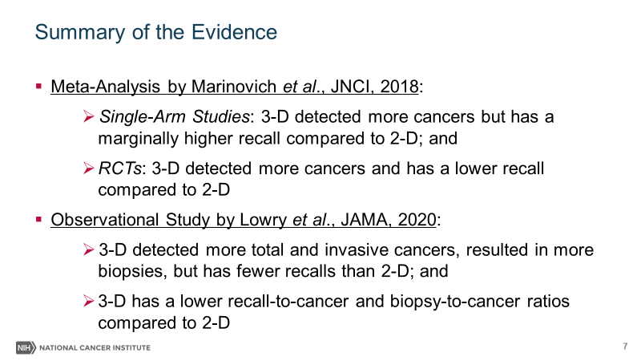
Summary of the Evidence

- Meta-Analysis by Marinovich et al., JNCI, 2018
- Single-Arm Studies. 3-D detected more cancers but had a marginally higher recall compared to 2-D; and
- Two-Arm Studies (RCTs). 3-D detected more cancers and had a lower recall compared to 2-D
- Observational Study by Lowry et al., JAMA, 2020
- 3-D detected more total and invasive cancers, resulted in more biopsies, but had fewer recalls than 2-D; and
- 3-D had a lower recall-to-cancer and biopsy-to-cancer ratios compared to 2-D

Since the start of TMIST in 2017, two informative analyses on 2-D vs. 3-D mammography have been published.

A meta-analysis by Marinovich et al reported slightly different findings on recall rates for 2-D vs. 3-D mammography, based on the type of study conducted. However, both types of studies found an increase in cancer detection.

In addition, an observational study from 1.6 million screening examinations by Lowry et al found that 3-D mammography reduces recall rates and detects more breast cancer, including invasive breast cancer, compared to 2-D.

SLIDE 8
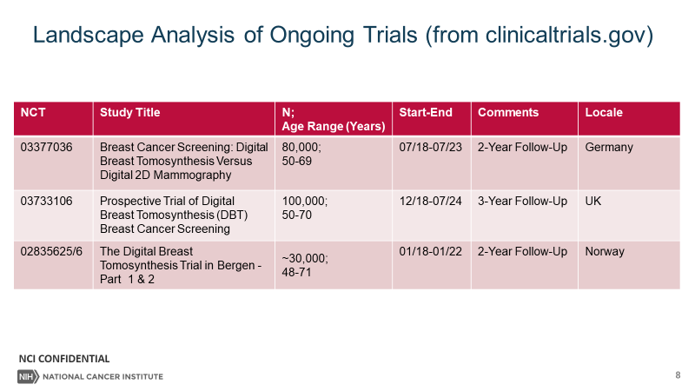

Landscape Analysis of Ongoing Trials (fromclinicaltrials.gov)
NCT | Study Title | N;  Age Range (Years) | Start-End | Follow-Up | Locale
03377036 | Breast Cancer Screening: Digital Breast Tomosynthesis Versus  Digital 2D Mammography | 80,000;  50-69 | 07/18-07/23 | 2 Years | Germany
03733106 | Prospective Trial of Digital  Breast Tomosynthesis (DBT) Breast Cancer Screening | 100,000;  50-70 | 12/18-07/24 | 3 Years | UK
02835625/6 | The Digital Breast  Tomosynthesis Trial in Bergen - Part 1 & 2 | ~30,000;  48-71 | 01/18-01/22 | 2 Years | Norway
There are three such trials of 2-D vs. 3-D mammography in Europe, all of which started after TMIST and are projected to be completed in the next 4 years. Other trials have experienced delays due to COVID and we do not know when they will be completed. In the UK, for example, screening mammography has been suspended for 6 months due to COVID, and, as a consequence, the trial consenting rate has been lower than anticipated. The UK trial has only enrolled 8,000, or 8% of its target to date, even though it opened in late 2018. Thus, it may not be feasible to conduct these trials in general and especially in the COVID era, at least not independently.

Regardless of the screening method, some of the same clinical questions about breast cancer screening remain unanswered:

- How best to screen women with dense breasts, given that their higher risk is compounded by poor performance of imaging methods compared to women without dense breasts?
- What is the best management of screen+ women since most screen+ women do not have findings considered “clinically” important?

SLIDE 9
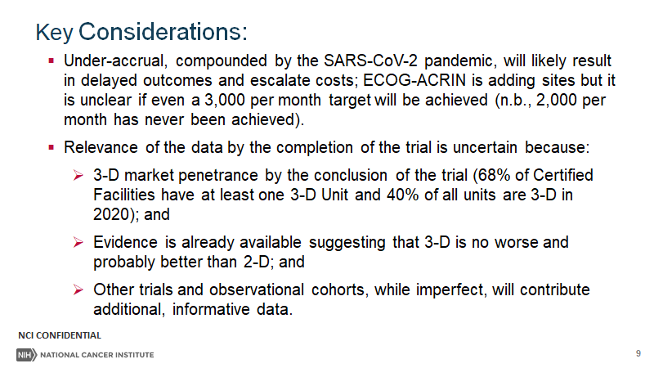

Key Considerations
- Under-accrual, compounded by the SARS-CoV-2 pandemic, will likely result in delayed outcomes and escalate costs; ECOG-ACRIN is adding sites but it is unclear if a 3,000-per-month accrual ever will be achieved (n.b., 2,000 per month has never been achieved).

- Relevance of the data by the completion of the trial is uncertain because:
- 3-D market penetrance by the conclusion of the trial (68% of Certified Facilities have at least one 3-D Unit and 40% of all units are 3-D in 2020); and
- Evidence is already available suggesting that 3-D is no worse and probably better than 2-D; and
- Other trials and observational cohorts, while imperfect, will contribute additional, informative data.

SLIDE 10

Final Comments & NCAB Advice Sought

- As initially conceived, TMIST will not complete accrual until 2023 (if 3,500 enrolled per month) or 2026 (if 2,000 enrolled per month)(vs. mid-2020 completion). There could be further delays if there is a long-term impact of the pandemic.
- Follow-up (~5 years) and primary data analysis (~1 year) will add ~6 years after enrollment i.e., completion and reporting of the data between 2029 and 2032 (vs. 2025).
- Ongoing breast cancer screening trials will report their results well before then, and radiological practice likely will change substantially during that interval.
- We propose the creation of Working Group, reporting to Clinical Trials and Translational Research Advisory Committee, to examine the utility of TMIST given these unanticipated challenges due to the pandemic.

Let me be very clear. TMIST is continuing while these issues are given consideration. The Central IRB has approved continuation of TMIST. Both NCI and ECOG-ACRIN remain committed to the study and to the women who have enrolled and are enrolling.

Given the state of the science and other factors, now is the time to re-evaluate TMIST’s feasibility and relevance. We look forward to collaborating with the working group and the stakeholders to chart the best course forward.

Finally, I want to thank the NCAB for their time, this opportunity to provide them with an update, and their consideration in this matter. I will take any questions, please.

